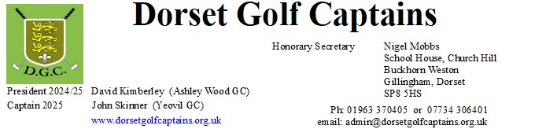
Dorset Golf Captains Annual Dinner 2025
was held at
The Dorset Golf and Country Club
on
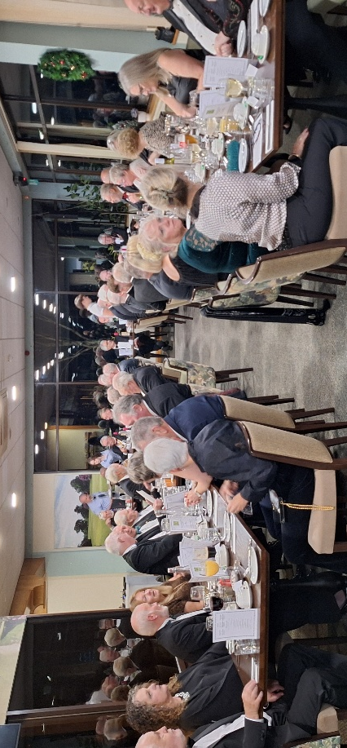
Friday 14th November

Pre-dinner golf was somewhat curtailed by Claudia (the storm, not Winkleman) with only 9 holes being played in somewhat soggy conditions.

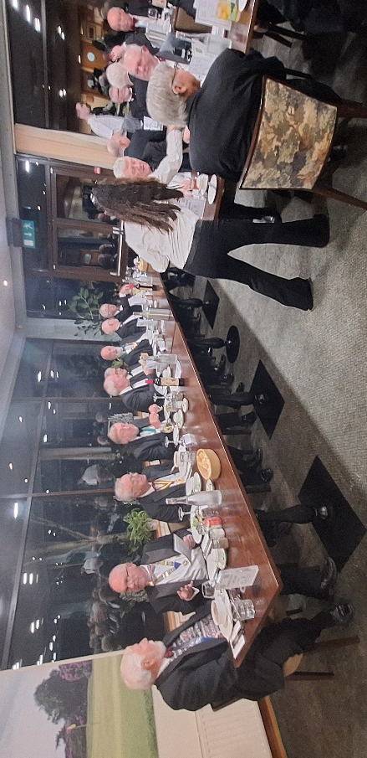
That dissappointment was soon forgotten during the excellent evening dinner and entertainment that followed.

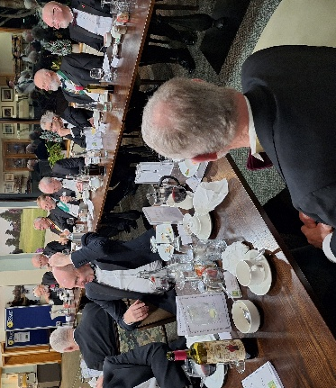
At the dinner we hosted Presidents, Captains and Secretaries from Somerset, Wiltshire, Oxfordshire, Berkshire, Surrey and Sussex.

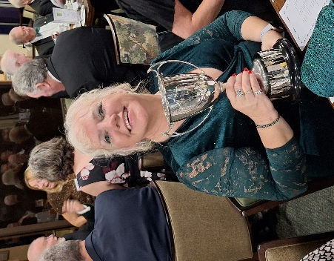

Our Captains speech was joyously interrupted by his wife Paula, Captain of the Past Lady Captains, waving the winners trophy as he announced the result of the match against the ladies.

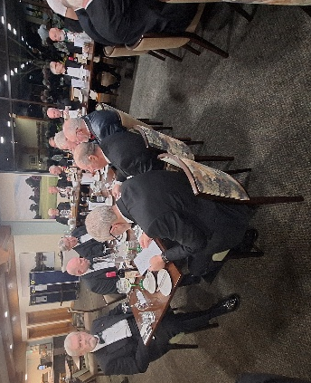
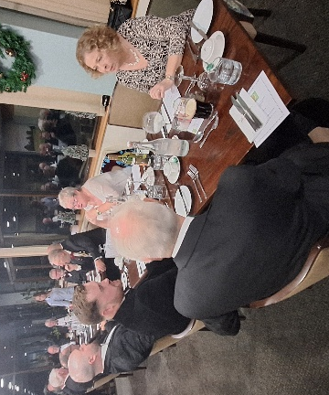
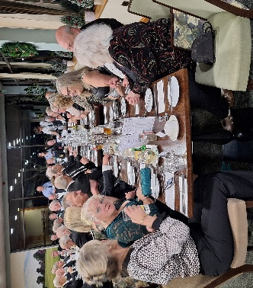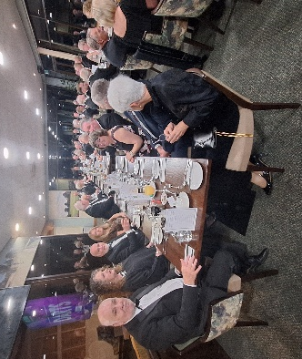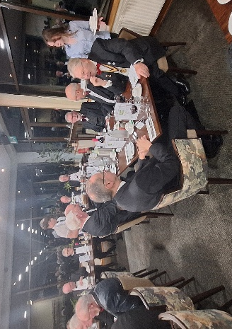
After the main course our guest speaker, Mr Richard Linley, retired National Hunt jockey and Senior Inspector of Courses gave a very interesting and amusing talk on his career and experiences.
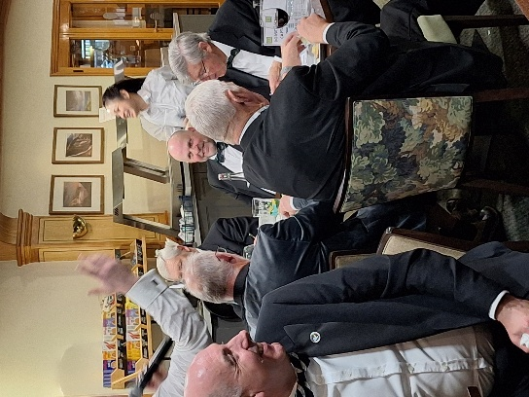
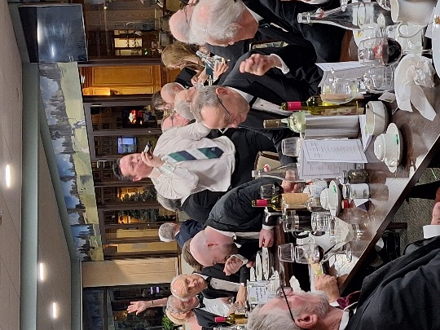
As sweet was being served one of the waiting staff fell in between the tables while carrying a tray of cutlery. As he got up, he produced a microphone, told everyone he was not one of the waiters and burst into song with Let Me Entertain You. One of the waitresses, also in on the act, joined him and they proceeded to entertain us with several well-known songs.
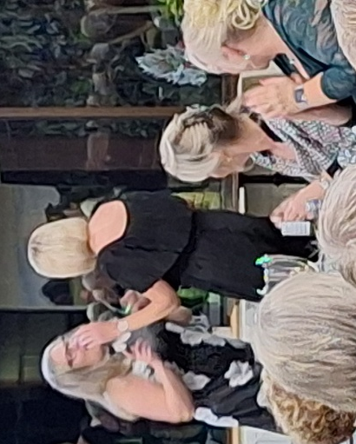

Once the diners got over the initial shock everyone joined in with the singing as our lady guests, unable to contain themselves sitting down, took to the dance floor.

During a very enjoyable evening, our Captain, Mr John Skinner, produced the 18th flag from the AIG Women’s Open Royal Porthcawl. It had been framed alongside photographs of Georgia Hall and Charlie Hull. Both players had signed the flag. John reminded us of our match against Gloucester where the visiting Captain, who was unable to attend, had fund raised for the MND Charity for 20 years and had been struck down with the disease himself. The flag was sold for the magnificent sum of £500.00, and the money is to be sent to Gloucester Captain’s from Dorset Captain’s in support of the MND Charity.
(Report & photos courtesy of Phil Purvis, Vice-Captain DGC)
A GREAT EVENING SADLY NOT AS WELL SUPPORTED AS ONE WOULD WISH

